# Significance of DevOps

The primary goal of DevOps is to enable organizations to deliver high-quality software products more efficiently and reliably. The significance of DevOps lies in several key areas:

Faster Delivery of Software:

Improved Collaboration:

Enhanced Quality and Stability:

Increased Efficiency and Productivity:

Reduced Time-to-Market:

Continuous Monitoring and Feedback:

Flexibility and Adaptability:

Cost Savings:

Scalability:

Cultural Transformation:

# Tech-Stack of Amazon

(According to StackShare)

## Application and Data

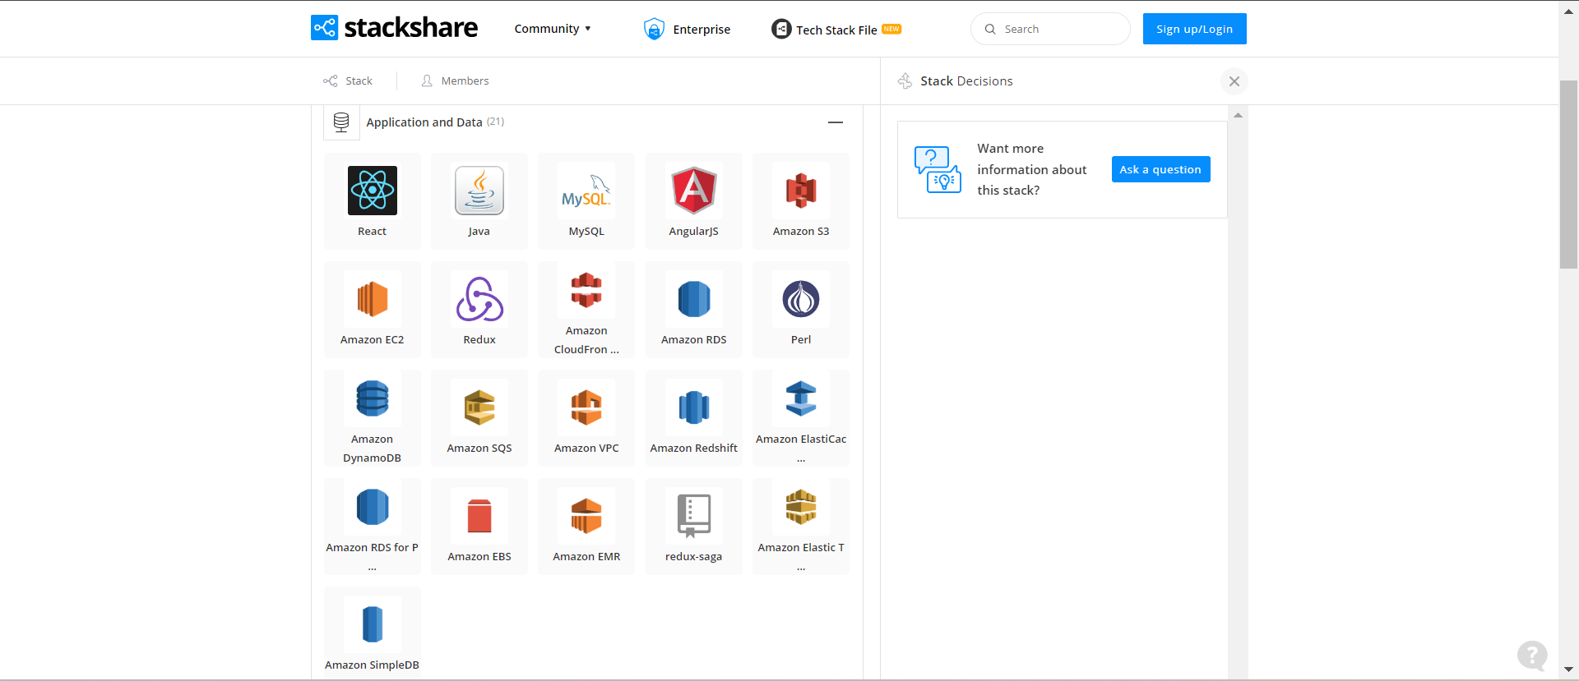

## Utilities

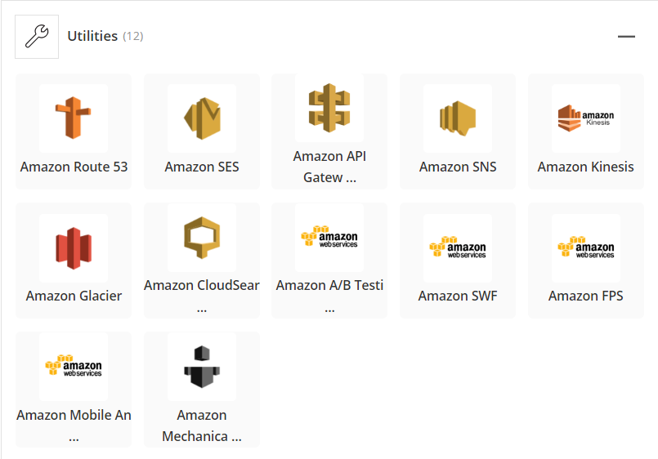

## DevOps



## Business Tools



## Packages



# Git Installation on local system



Import Repository

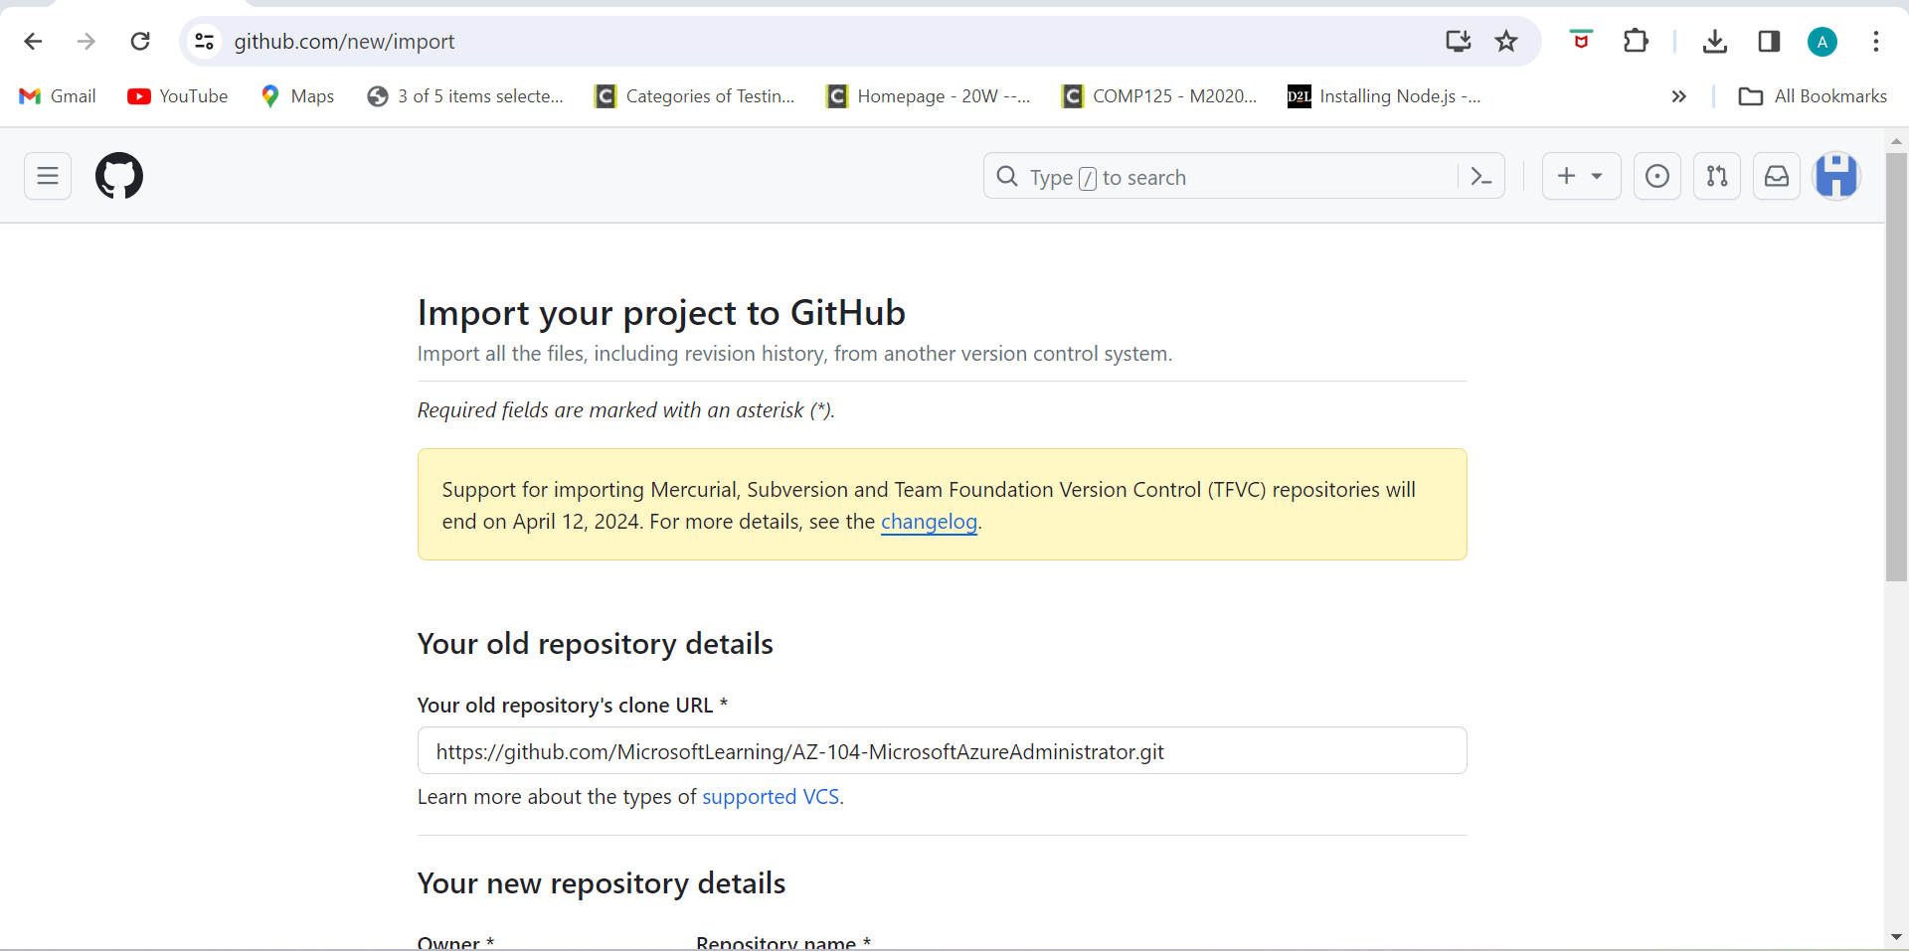



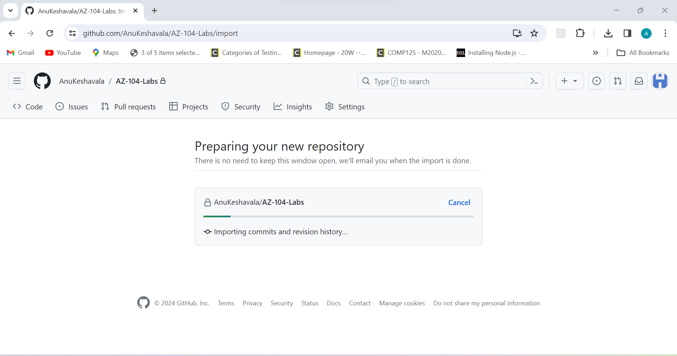

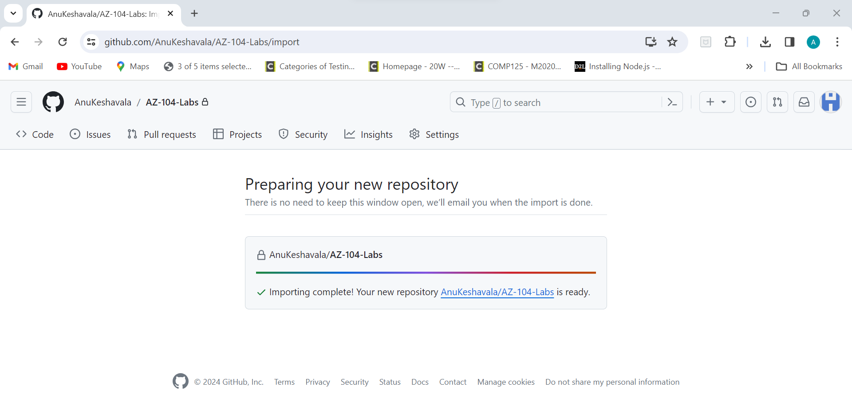

Imported the Repository and Created it as a Private Repository:

